**WEB PROGRAMMING:**

**HTML INTRODUCTION:**

**TASK_1**

**CODE:**

<!DOCTYPE html>

<html lang="en">

<head>

  <meta charset="utf-8" />

  <meta name="viewport" content="width=device-width, initial-scale=1" />

  <title>Task 1 Lab 3</title>

  <link rel="stylesheet" href="t1.css" />

  <link href="https://cdn.jsdelivr.net/npm/bootstrap@5.3.2/dist/css/bootstrap.min.css" rel="stylesheet"

    integrity="sha384-T3c6CoIi6uLrA9TneNEoa7RxnatzjcDSCmG1MXxSR1GAsXEV/Dwwykc2MPK8M2HN" crossorigin="anonymous" />

  <style>

    .container {

      background-color: white;

    }

    .decoration {

      text-decoration: none;

    }

  </style>

</head>

<body>

  <div class="container">

    <a class="decoration" href="https://www.w3schools.com/bootstrap/bootstrap_ver.asp">

      <div class="bg-success text-success bg-opacity-50 s">Feel good about bootstrap</div>

    </a>

    <a class="decoration" href="https://www.w3schools.com/bootstrap/bootstrap_ver.asp">

      <div class="text-success bg-primary bg-opacity-25 s">Feel Informed about bootstrap</div>

    </a>

    <a class="decoration" href="https://www.w3schools.com/bootstrap/bootstrap_ver.asp">

      <div class="text-warning bg-warning bg-opacity-25 s">Feel warned about Bootstrap</div>

    </a>

    <a class="decoration" href="https://www.w3schools.com/bootstrap/bootstrap_ver.asp">

      <div class="text-warning bg-warning bg-opacity-25 s">Maybe I should read the docs...</div>

    </a>

    <a class="decoration" href="https://www.w3schools.com/bootstrap/bootstrap_ver.asp">

      <div class="bg-danger text-danger bg-opacity-25 s">Danger zone</div>

    </a>

    <a class="decoration" href="https://www.w3schools.com/bootstrap/bootstrap_ver.asp">

      <div class="bg-danger text-danger bg-opacity-25 s">I really should read the docs...</div>

    </a>

  </div>

  <script src="https://cdn.jsdelivr.net/npm/bootstrap@5.3.2/dist/js/bootstrap.bundle.min.js"

    integrity="sha384-C6RzsynM9kWDrMNeT87bh95OGNyZPhcTNXj1NW7RuBCsyN/o0jlpcV8Qyq46cDfL"

    crossorigin="anonymous"></script>

</body>

</html>

**OUTPUT:**

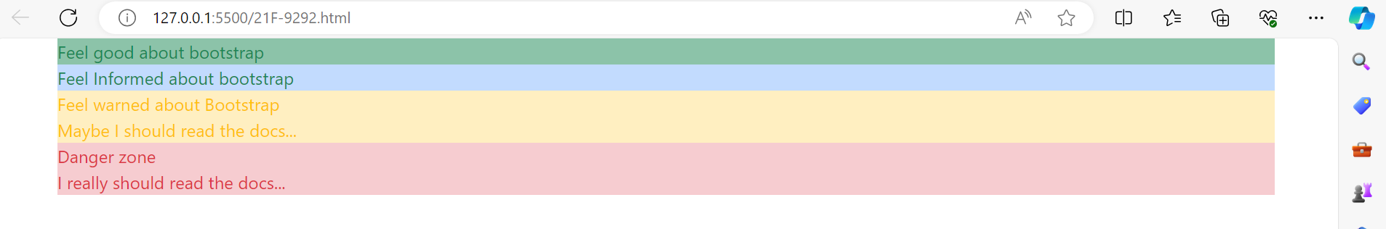

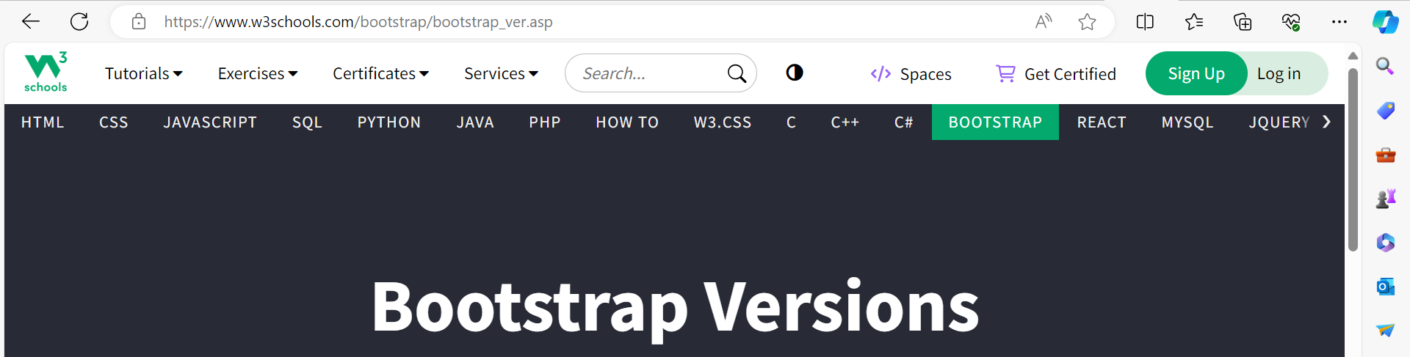

**TASK_2**

**CODE:**

<!DOCTYPE html>

<html lang="en">

<head>

  <meta charset="utf-8" />

  <meta name="viewport" content="width=device-width, initial-scale=1" />

  <title>Task2 Lab3</title>

  <link rel="stylesheet" href="t1.css" />

  <link href="https://cdn.jsdelivr.net/npm/bootstrap@5.3.2/dist/css/bootstrap.min.css" rel="stylesheet"

    integrity="sha384-T3c6CoIi6uLrA9TneNEoa7RxnatzjcDSCmG1MXxSR1GAsXEV/Dwwykc2MPK8M2HN" crossorigin="anonymous" />

</head>

<style>

  .container {

    background-color: white;

  }

</style>

<body>

  <div class="container">

    <button type="button" class="btn">Basic</button>

    <button type="button" class="btn btn-primary">Primary</button>

    <button type="button" class="btn btn-secondary">Secondary</button>

    <button type="button" class="btn btn-success">Success</button>

    <button type="button" class="btn btn-info">Info</button>

    <button type="button" class="btn btn-warning">Warning</button>

    <button type="button" class="btn btn-danger">Danger</button>

    <button type="button" class="btn btn-dark">Dark</button>

    <button type="button" class="btn btn-light">Light</button>

    <button type="button" class="btn btn-link">Link</button>

  </div>

  <script>

    let buttons = document.getElementsByClassName("btn");

    for (let j = 0; j < buttons.length; j++) {

      buttons[j].addEventListener("click", function () {

        alert("My name is ALI IMTIAZ");

      });

    }

  </script>

  <script src="https://cdn.jsdelivr.net/npm/bootstrap@5.3.2/dist/js/bootstrap.bundle.min.js"

    integrity="sha384-C6RzsynM9kWDrMNeT87bh95OGNyZPhcTNXj1NW7RuBCsyN/o0jlpcV8Qyq46cDfL"

    crossorigin="anonymous"></script>

</body>

</html>

**OUTPUT:**



**TASK_3**

**CODE:**

<!DOCTYPE html>

<html lang="en">

<head>

  <meta charset="utf-8" />

  <meta name="viewport" content="width=device-width, initial-scale=1" />

  <title>Task 3 Lab 2</title>

  <link rel="stylesheet" href="t1.css" />

  <link href="https://cdn.jsdelivr.net/npm/bootstrap@5.3.2/dist/css/bootstrap.min.css" rel="stylesheet"

    integrity="sha384-T3c6CoIi6uLrA9TneNEoa7RxnatzjcDSCmG1MXxSR1GAsXEV/Dwwykc2MPK8M2HN" crossorigin="anonymous" />

</head>

<style>

  .custom-button {

    color: white;

    background-color: teal;

  }

</style>

<body>

  <div>

    <input id="firstNumber" placeholder="Enter the 1st number" />

    <input id="secondNumber" placeholder="Enter the 2nd number" />

    <input id="result" placeholder="Result" />

  </div>

  <br />

  <button class="custom-button" id="addButton" onclick="performAddition()">Addition</button>

  <button class="custom-button" id="subtractButton" onclick="performSubtraction()">Subtraction</button>

  <button class="custom-button" id="multiplyButton" onclick="performMultiplication()">Multiplication</button>

  <button class="custom-button" id="divideButton" onclick="performDivision()">Division</button>

  <script src="t1.js"></script>

  <script src="https://cdn.jsdelivr.net/npm/bootstrap@5.3.2/dist/js/bootstrap.bundle.min.js"

    integrity="sha384-C6RzsynM9kWDrMNeT87bh95OGNyZPhcTNXj1NW7RuBCsyN/o0jlpcV8Qyq46cDfL"

    crossorigin="anonymous"></script>

  <script>

    let addButton = document.getElementById("addButton");

    let subtractButton = document.getElementById("subtractButton");

    let multiplyButton = document.getElementById("multiplyButton");

    let divideButton = document.getElementById("divideButton");

    let performAddition = () => {

      let firstNumber = Number(document.getElementById("firstNumber").value);

      let secondNumber = Number(document.getElementById("secondNumber").value);

      console.log(firstNumber + secondNumber);

      document.getElementById("result").value = firstNumber + secondNumber;

    };

    let performSubtraction = () => {

      let firstNumber = Number(document.getElementById("firstNumber").value);

      let secondNumber = Number(document.getElementById("secondNumber").value);

      console.log(firstNumber - secondNumber);

      document.getElementById("result").value = firstNumber - secondNumber;

    };

    let performMultiplication = () => {

      let firstNumber = Number(document.getElementById("firstNumber").value);

      let secondNumber = Number(document.getElementById("secondNumber").value);

      console.log(firstNumber * secondNumber);

      document.getElementById("result").value = firstNumber * secondNumber;

    };

    let performDivision = () => {

      let firstNumber = Number(document.getElementById("firstNumber").value);

      let secondNumber = Number(document.getElementById("secondNumber").value);

      console.log(firstNumber / secondNumber);

      document.getElementById("result").value = firstNumber / secondNumber;

    };

  </script>

</body>

</html>

**OUTPUT:**

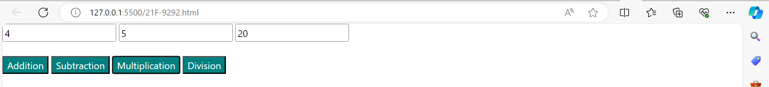

**TASK_4**

**CODE:**

<!DOCTYPE html>

<html lang="en">

<head>

  <meta charset="utf-8" />

  <meta name="viewport" content="width=device-width, initial-scale=1" />

  <title>js Task4</title>

  <link rel="stylesheet" href="t1.css" />

  <link href="https://cdn.jsdelivr.net/npm/bootstrap@5.3.2/dist/css/bootstrap.min.css" rel="stylesheet"

    integrity="sha384-T3c6CoIi6uLrA9TneNEoa7RxnatzjcDSCmG1MXxSR1GAsXEV/Dwwykc2MPK8M2HN" crossorigin="anonymous" />

</head>

<style>

  .custom-container {

    background-color: white;

  }

  .custom-header {

    color: red;

    margin-left: 50px;

  }

  .custom-button {

    color: white;

    background-color: MediumSeaGreen;

    margin-left: 40px;

  }

</style>

<body>

  <input id="inputMonth" type="text" placeholder="Enter Month Name" />

  <h1 class="custom-header" id="days"></h1>

  <button class="custom-button" id="submitButton" onclick="submitForm()">Submit</button>

  <script src="t1.js"></script>

  <script src="https://cdn.jsdelivr.net/npm/bootstrap@5.3.2/dist/js/bootstrap.bundle.min.js"

    integrity="sha384-C6RzsynM9kWDrMNeT87bh95OGNyZPhcTNXj1NW7RuBCsyN/o0jlpcV8Qyq46cDfL"

    crossorigin="anonymous"></script>

  <script>

    let submitForm = () => {

      let day = 0;

      let inputMonth = document.getElementById("inputMonth").value;

      if (

        inputMonth == "Jan" ||

        inputMonth == "Mar" ||

        inputMonth == "Ma" ||

        inputMonth == "Jul" ||

        inputMonth == "Aug" ||

        inputMonth == "Oct" ||

        inputMonth == "Dec"

      ) {

        day = 31;

      } else if (

        inputMonth == "Apr" ||

        inputMonth == "Jun" ||

        inputMonth == "Sep" ||

        inputMonth == "Nov"

      ) {

        day = 30;

      } else if (inputMonth == "Feb") {

        day = 28;

      }

      document.getElementById("days").innerHTML = `${day}`;

    };

  </script>

</body>

</html>

**OUTPUT:**

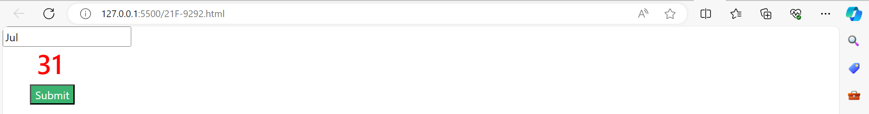

**TASK_5**

**CODE:**

<!DOCTYPE html>

<html lang="en">

<head>

  <meta charset="utf-8" />

  <meta name="viewport" content="width=device-width, initial-scale=1" />

  <title>Task 5 Lab 3 </title>

  <link rel="stylesheet" href="t1.css" />

  <link href="https://cdn.jsdelivr.net/npm/bootstrap@5.3.2/dist/css/bootstrap.min.css" rel="stylesheet"

    integrity="sha384-T3c6CoIi6uLrA9TneNEoa7RxnatzjcDSCmG1MXxSR1GAsXEV/Dwwykc2MPK8M2HN" crossorigin="anonymous" />

</head>

<style>

  .custom-button {

    color: white;

    background-color: MediumSeaGreen;

    margin-left: 30px;

  }

</style>

<body>

  <input id="inputNumber" type="Number" placeholder="Enter number for which u want table" />

  <h1 id="table"></h1>

  <button class="custom-button" id="submitButton" onclick="generateTable()">Submit</button>

  <script src="t1.js"></script>

  <script src="https://cdn.jsdelivr.net/npm/bootstrap@5.3.2/dist/js/bootstrap.bundle.min.js"

    integrity="sha384-C6RzsynM9kWDrMNeT87bh95OGNyZPhcTNXj1NW7RuBCsyN/o0jlpcV8Qyq46cDfL"

    crossorigin="anonymous"></script>

  <script>

    let generateTable = () => {

      let number = Number(document.getElementById("inputNumber").value);

      let tableContainer = document.createElement("div");

      tableContainer.classList.add("table");

      for (let i = 1; i <= 10; i++) {

        let result = document.createElement("h3");

        let multiplicationResult = number * i;

        result.innerHTML = `${number} * ${i} = ${multiplicationResult}`;

        result.style.color = "red";

        tableContainer.appendChild(result);

      }

      document.getElementById("table").appendChild(tableContainer);

    };

  </script>

</body>

</html>

**OUTPUT:**

